**Installation and Configuration of NoSQL database –MongoDB**

### Navigate to the download site

Cross-check the Specifications and Download MongoDB

Under the Software section, click on the Community server version.

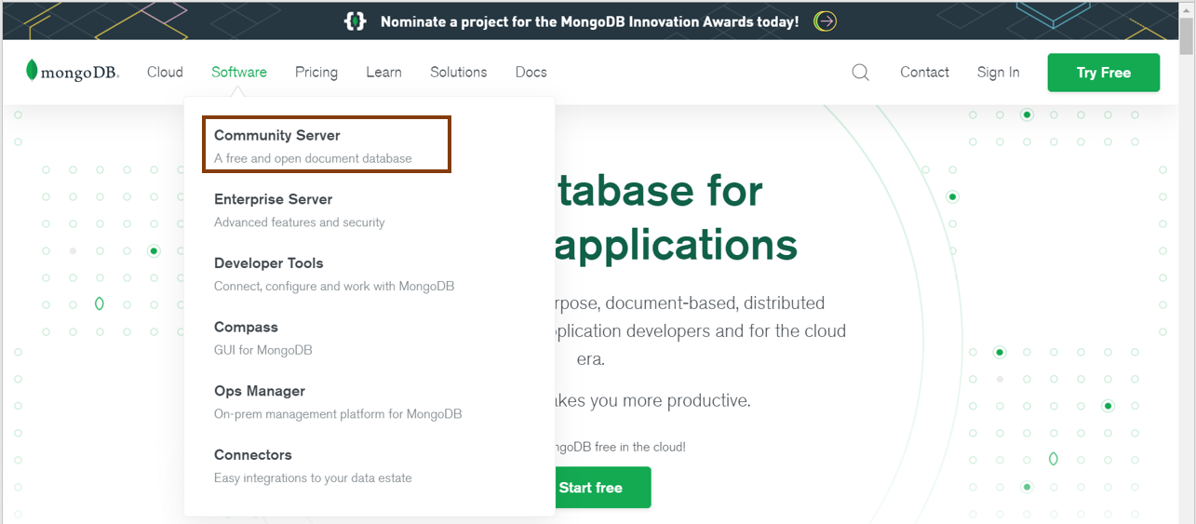

Make sure that the specifications to the right of the screen are correct. At the time of writing, the latest version is 4.4.5. Ensure that the platform is Windows, and the package is MSI. Go ahead and click on download.

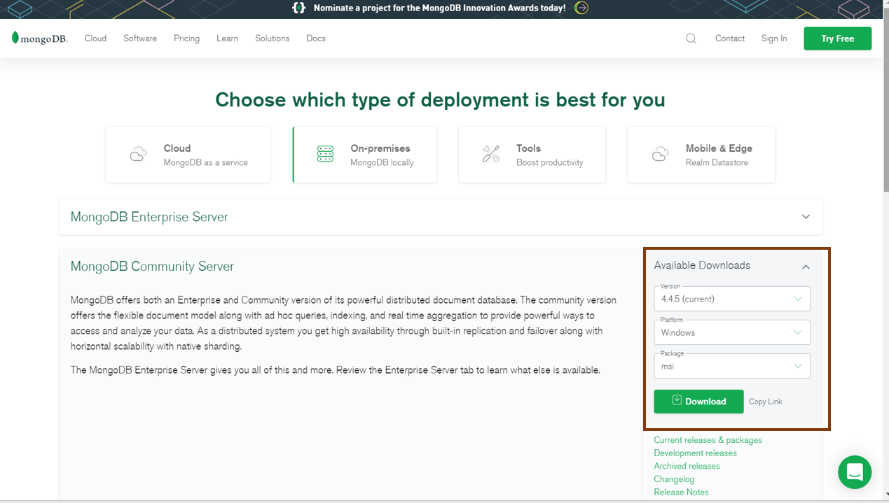

## **MongoDB Installation**

You can find the downloaded file in the downloads directory. You can follow the steps mentioned there and install the software.

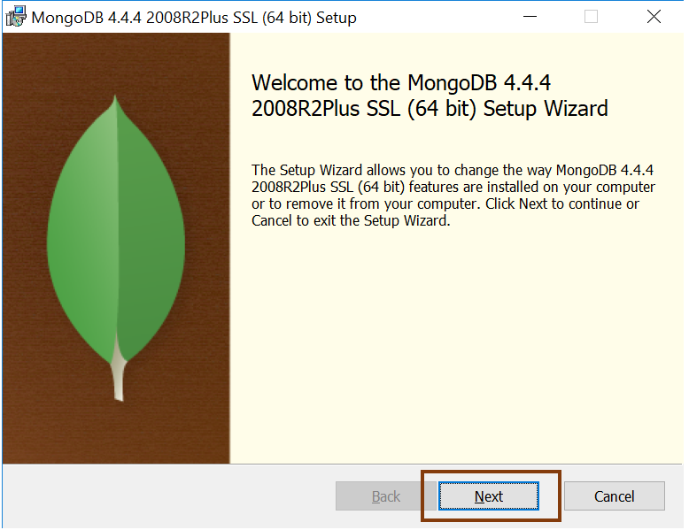

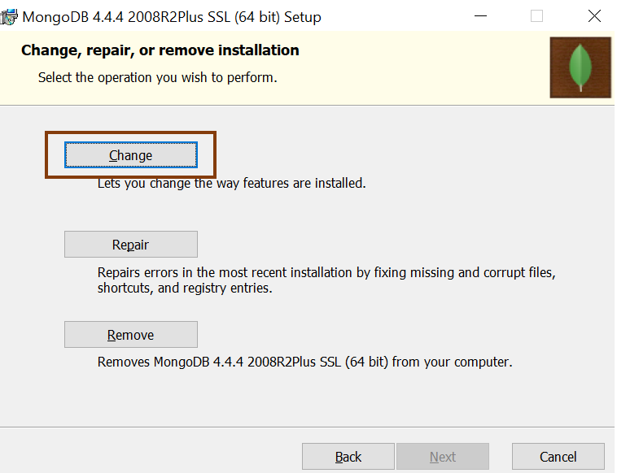

On completing the installation successfully, you will find the software package in your C drive. C:\Program Files\MongoDB\Server\4.4\bin.

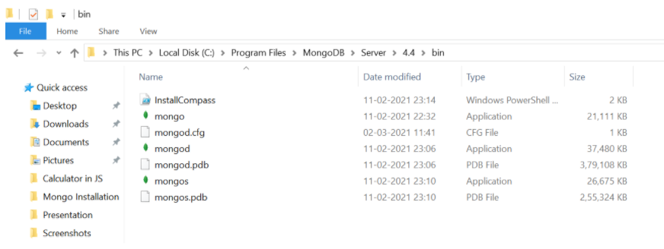

You can see that there are mongo and mongod executable files. The mongod file is the daemon process that does the background jobs like accessing, retrieving, and updating the database.

## **Create an Environment Variable**

It’s best practice to create an environment variable for the executable file so that you don’t have to change the directory structure every time you want to execute the file.

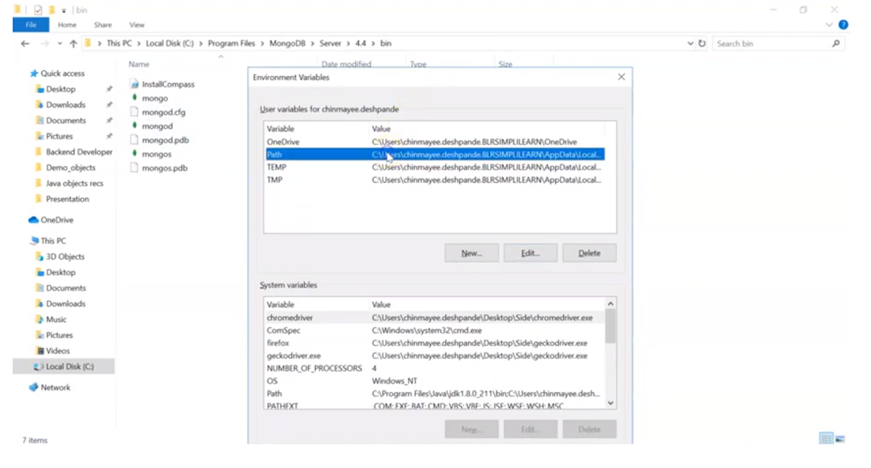

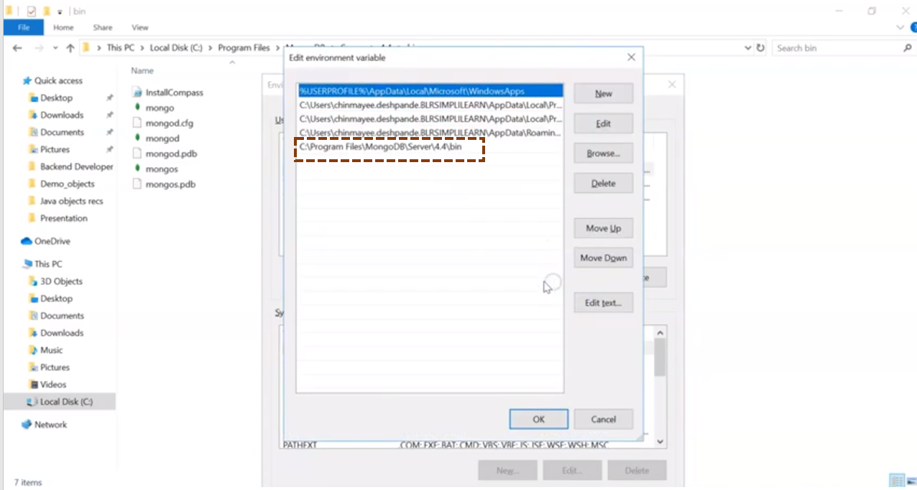

## **Execute the Mongo App**

After creating an environment path, you can open the command prompt and just type in mongo and press enter.

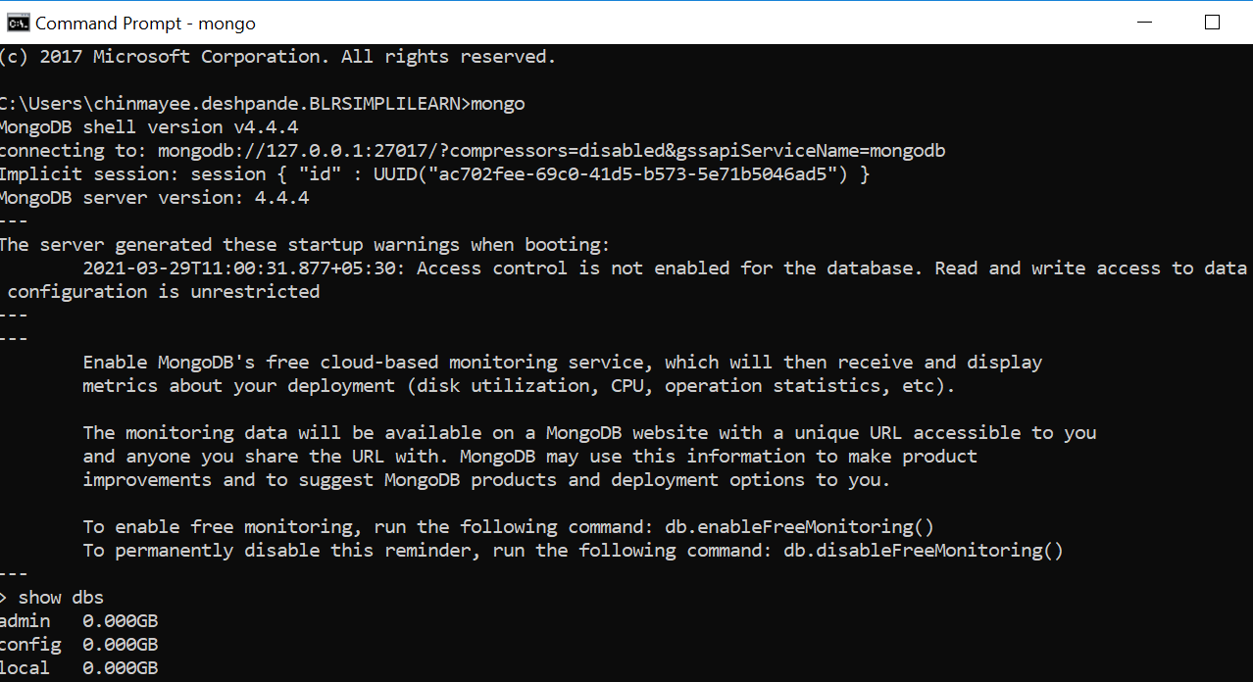

The mongo server is then generated and is up and running.

## **Verify the Setup**

To verify if it did the setup correctly, type in the command show DBS.

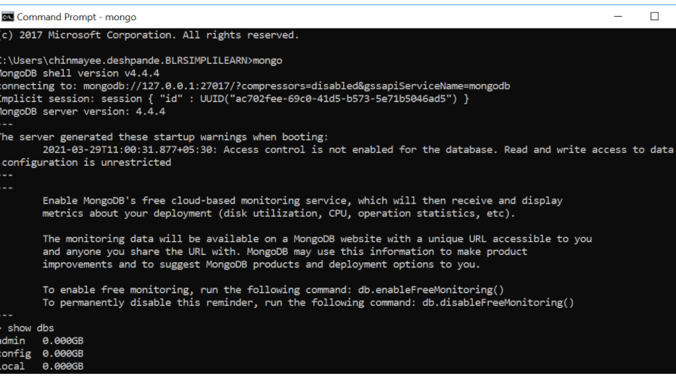

With that, you have successfully installed and set up MongoDB on your Windows system.

